Tucson Community School
Classroom Participation Training Packet

Tucson Community School is a cooperative school, this means that each TCS family is an important member of the larger school community. Every aspect of the school’s essential functions depends on the participation of each our community members. This packet is a guideline for family members who will be helping in the classrooms and playground during the school day.

Classroom Helper Days
As a member of TCS, your family will participate in your child’s classroom during the morning program (8:30-12:00 pm) at least seven (7) days during the school year. Remember, parents, grandparents, aunt, uncle, nanny, or any individual with a caring, sustained relationship with you and your child are all welcome to assist in the classroom. We ask that you let your teacher know who will be in the classroom. In addition, any caregiver participating with your child should read Classroom Participation Training Packet before arriving.
Unexpected Absence
Because our teachers plan their curriculum with family participation in mind, families must leave a message with the office and/or your teacher if unexpected illness or other circumstances result in their inability to work the scheduled classroom parent helper day. If a family is unable to work on their scheduled day for any reason, they are responsible to reschedule their helper days. A missed classroom helper day will be charged at $50/per hour.

What will I be doing in the classroom?
This is your opportunity to observe your child with other children, share insights and experiences of TCS teachers and parents regarding child’s growth and development and assist the teaching team.
(1) Observe your child with other children. Participate in the day.
We believe children learn best by experiencing long blocks of uninterrupted, hands-on play/learning. TCS teachers accomplish this by offering many opportunities to explore and play, paying close attention to children’s interests and developing themes or projects through which the children can expand their knowledge and skills in various areas. Read “Guidelines in The Classroom” to know how to meet the children’s needs throughout the day.
(2) Share insights and experiences of TCS teachers and parents regarding your child’s growth and development.
TCS is a safe and secure environment for your child to begin building relationships, explore, discover and learn. Our staff is constantly engaging, observing and analyzing our children to help in their growth and development. As you participate in the classroom and observe your child, share your thoughts on your child’s growth and development or ask about what you have observed. The best time to share these observations is on a Parent Feedback Form available in the classroom, after class, in an email or during a personal parent, teacher conference. Please do not engage teachers in discussions during class time. The children are their #1 priority.
(3) Help with classroom duties.
TCS has spacious indoor and outdoor classrooms. Our ability to allow our children to explore inside and outside is primarily due to our small class sizes and your participation. Your primary responsibility is to assist the teacher in carrying out the day's program. General classroom tasks include setting out play material, setting up the play yard, supervising an activity once it is organized, setting up snack, helping children in routines of washing, cleaning up snack, helping the children put away materials and equipment. Be sure to read the play yard and classroom guidelines in this packet. Check the “Parent’s Corner” of each your child’s classroom on notes of the day’s specific activities.

Guidelines for Classroom Helping
The primary responsibility of a classroom helping parent/adult is to assist the teacher in carrying out the day's program. Specified routines are posted in each room. In addition, each teacher provides additional information on assisting within their classroom environment.

Adhering to the following guidelines will promote consistency in meeting the children's needs while enriching your experience in the classroom. The following guidelines avoid confusing the children with a variety of approaches.
- Model respect for all people: staff, other parents and children.
- Give the children undivided attention. Discussion with other adults should be brief or held outside. Cell phones must be off when in the classroom. If a vital call is expected, a mobile phone may reside in the office, with the Business Manager, who will notify the parent if a call comes in. Emergency mobile phone conversations should only take place in the kitchen, or outside of campus.
- Parents should be always aware of their surroundings and the children. All children should be visible and be able to be always heard by an adult.
- Record all interesting observations or questions on the Parent Feedback Forms available in the classroom and leave for the teacher to review at the end of the morning.
- Always observe all children. If parents have concerns, please communicate them directly to the teacher (during moments when they are not directly involved with children) and respect all children’s right to confidentiality. The best time to do this is after class, by phone, email or via our Parent Feedback Form (available in every classroom).
- Only an adult with required Fingerprint Clearance Card and cleared background check and the child’s parent may assist a child with toileting.
- Arrive on time and wash hands upon arrival. There is no need to arrive early.
- Dress in comfortable clothes suitable for getting dirty.
- Show children all the love and affection they seek, especially if they hurt themselves or have their feelings hurt.
- Maintain a pleasant calm manner, as well as a positive and courteous attitude.
- Give children a chance to solve their own problems. Remain close by but in the background prepared to help if necessary. This can be hard but allowing the children to work out problems themselves can produce wonderful results. It is necessary to intervene immediately if anything seen or heard would result in physical harm to another individual.
- Reverse or avoid an undesirable situation indirectly by controlling the environment when possible. (For example: if a child is about to knock over another child's block tower, try to avoid the catastrophe by calmly calling the child’s name and redirecting the child to some other interesting activity as you walk closer to the situation.)
- Make sure you have the child's attention before you speak. Lower yourself to the child’s eye level, lock gazes and state your request simply, using a quiet, calm voice and simple language.
- Give positive instructions telling the child what is desired. (For example: “Please put paper towels only in the wastebasket” rather than, “Do not put the paper towels in the toilet”).
- Give logical reasons for requests or directions. Insisting on blind obedience can hinder a child's development. (For example: “We wear aprons while painting to help keep paint off our clothes” or “We place paper towels only in the wastebaskets because they are too big and thick to flush down the toilet”).
- Assist children in making clear choices about what they want to do.
- Be clear as to whether you are really offering the child a choice. (For example: “Would you like water now?” offers a choice; “It is time for water now” does not offer a choice).
- Avoid entering the play situation as if you were a child.
- Avoid over stimulating the children.
- Call on the teacher if uncertain about a situation.
- Your child may act differently when you are here. Please do not hesitate to ask a teacher for assistance if you are finding it difficult to help with all the children.

Play Yard Guidelines
- Slides: Only one child on the slide at a time. All waiting children must wait on the ground. Children go down the slide feet first.
- Tall White Circle Climber: Only one child at a time on the circle climber. Often children climb up with ease but can’t get down. Carefully talk them down, giving instruction one limb at a time.
- Wooden Structures: One child at a time on the very top of any wooden structure. Children must walk on the wooden structure. One child should be on a climbing board at a time.
- Cone Climber: Only three children at a time on the cone climber.
- White Climber: Only three children at a time on the white climber.
- Gardens: Look at the garden; weed if you are sure about weed identification.
- Chickens: Extra snacks for the chickens are in the shed (mealworms) or in the fridge (scraps). Adults and children are not permitted in the coop without TCS staff present.
- Climbing: Never lift a child up to a bar, branch, or platform. If they can’t get there with their own power, they are not ready to be there. You can instruct them, saying for example, “Hold here, pull with your arms as you push with your legs.” If they are not able to climb to a desired spot, a supportive comment like, “Your hands are strong, keep working every day and your arms will soon get strong enough to pull you up there.”
- Wheel Toys: Trikes and bikes are used only on the concrete bikeway; wagon may go where they are needed. We encourage careful driving. Trikes, bikes and wagons must be returned to the parking lot or shed after use.
- Carpentry: Help children put on safety goggles and start the nails, if necessary. Verbally encourage them to watch the nail and hammer hard. Be sure that no sharp nails protrude. Help them with the clamp. Stay with the children at all times in this area. Put tools and nails away when not in use.
- Sand, Water and Digging Pits: Shovels are used in the digging pit. Help see that children have enough space to dig safely. Put shovels away when not in use.
- Swings: Push children who want help on the swing but be sure you understand what they mean when they ask to be pushed “high.” Sometimes “high” is just swinging very gently.
- Outdoor Block Building: This is a popular and constructive activity. Supervision is needed so falling boards and blocks do not hurt children.
Setting Up the Yard
Check with your child’s teacher or the “Parent Corner” information about specific items that may need to be set up that day. General set up of the yard includes:
- Remove tarps from digging pits. Fold them up and put them aside.
- Set up climbing boards. Secure them with pea gravel at the base or clips at the top
- Sweep debris from porches, patios and concrete pathways.
- Take out trikes/bikes from shed

Setting Up Snack
- Check snack calendar and number of children present for the day
- Put away activities on the tables.
- Wash off tables with towel and cleaning solution.
- Set chairs for each child and adult present
- Place one cup upside down and one napkin at each place setting.
- Bring water and any refrigerated snack from the kitchen, utilizing the rolling carts, if necessary.
- Help children wash their hands when it is time to gather for snack.
- Help serve the snack, if necessary. Allow children to serve themselves as appropriate. Be aware of children with dietary needs.

Cleaning Up Snack
- Wipe down tables. Sweep crumbs from floor.
- Take tray with used cups, utensils and serving dishes back to kitchen.
- Rinse cups and place in dishwasher. The dishwasher is reserved for cups and utensils. Hand wash any other serving dishes, utilizing the three-tub sink (see image below).
- Clean tray, if used, and store it back on black wire rack beside the refrigerator.
- Clean rolling cart and store back in the classroom.
- Place remaining, unused refrigerated snack back in the refrigerator. Place non-perishable, unused food in a sealed container or Ziploc bag in the pantry.

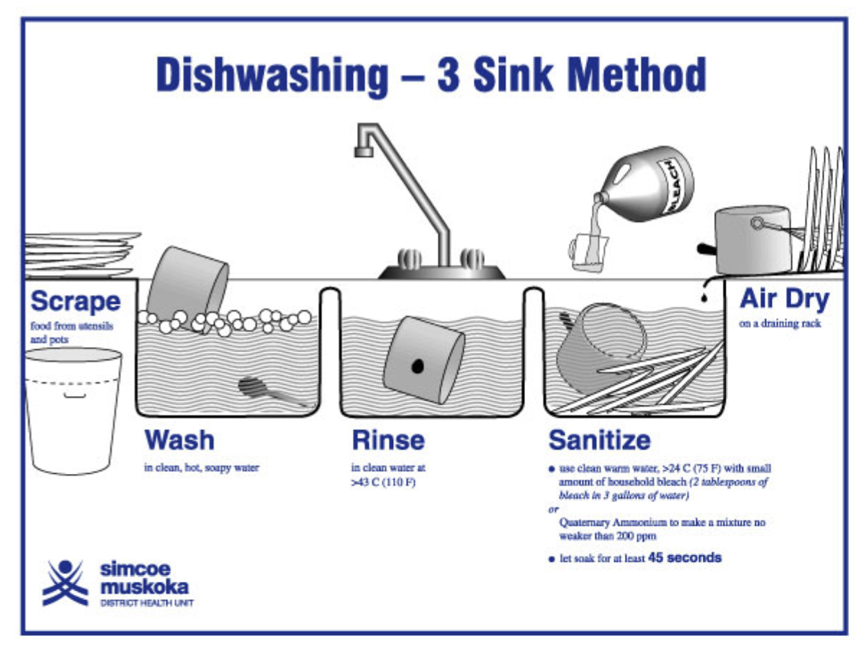
Morning Program Schedule
Monday - Friday, 8:30 am – 12:00 pm

This program listed below is flexible and serves as a guide for time sequences. Lesson plans with weekly learning objectives guide the indoor and outdoor actives, group projects and circle times. Changes are made according to the needs of the group as a whole and the individual needs of each child.

Time(s) | Activity
8:25 am – 8:35 am | - Children arrive, wash hands  - Greeting and attendance  - Choice of indoor/outdoor activities
8:30 am – 8:45 am | - Participating adults and children set up the play yard
9:00 am – 10:00 am | - Choice of indoor and/or outdoor activities  - Child-led investigations, invitations, and provocations  - Morning meeting/Community Time  - Adult prepares snack in Kitchen
9:50 am | - Adults’ clean tables and set up for snack
10:05 am | - Children wash hands and prepare for snack
10:10 am – 10:25 am | - Teachers, children, and families eat snack family style.  - After snack, adults’ clean tables and take snack cart to kitchen to clean and wash dishes.
10:35 am – 11:30 am | - Choice of indoor and/or outdoor activities  - Child-led investigations, invitations, and provocations  - Community Time/Teacher led activities such as music, movement, group discussions, and projects.
11:30 am | - Clean up – adults and children put yard tools away
11:55 am -12:00 pm | - Closing circle – a time to wish each other well as children transition to dismissal or lunch time

Engaging with Children During Learning Experiences

To help children think more deeply about what they are experiencing here at TCS, it can be helpful to engage children in sharing their thinking with open ended comments or questions that require more than a one-word answer. Example: “How did you figure that out? Which part of _____ was hardest? Tell me more. How do you know?”

At the Easel
When a child is painting, you might comment on the colors you see, or whether the lines are straight or wavy. When a child is finished with his painting, you might ask if you can hold it up in front of him so he can really appreciate from another angle. Rather than offer, “Good job” when a child creates something, ask them something about it. Not twenty questions. Not every time. But when you really want to know which part they did first, or how they thought of their idea, ask. The answers are often both heartwarming and insightful.

What Types of Activities Can Families Enjoy with Children:

- Art (easel painting, clay, play dough, crayons, finger painting, gluing, etc.)
- Inside Blocks
- Puzzles & Manipulative Toys
- Water Play
- Writing
- Books
- Care of Pets
- Music, Movement
- Cooking
- Science Experiments
- Digging
- Climbing
- Swinging
- Block-Building
- Wheel Toys
- Carpentry
- Gardening
- Pets
- Sliding
- Water Play
- Dramatic Play

